46. Phlebological days with international participation
Department of Anatomy, 2nd Faculty of Medicine, Prague
November 12-13th 2021
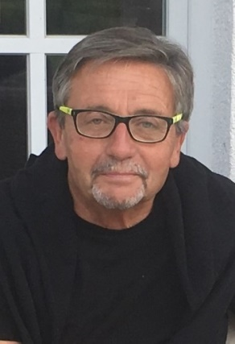

Dear friends of Czech Phlebology,
allow me to greet you on behalf of the CFLS Committee and the Committee of our Endovenous Section. Together with you, we all hope that this year's Phlebological Days will take place in the traditional full-time form, unless the current dismantling spoils everything again. But mainly due to vaccination, the initial situation is completely different.

The traditional form of the meeting was supported by the majority of the committee members, the section management and the advisory votes of the members of the audit committee. The organizers of the conference were decided in advance - prof. David Kachlík, head of the Department of Anatomy II. LF UK and his close clinical collaborator dr. Lukáš Hnátek, Chairman of the Endovenous Section of the CFLS, only slightly revived and supplemented the program, which was originally prepared for last year, in an excellent way. We will publish their invitation in the coming days. The co-organizer of this year's event will be II. Faculty of Medicine, Charles University, which will also provide the entire event free of charge with the premises of the Institute of Anatomy. Dean II. LF UK will be asked to sponsor our event. The CFLS Committee highly values ​​the co-organization and the provision of space for the 46th Phlebological Days by the 2nd Faculty of Medicine, Charles University.

Carefully read the preliminary program of this year's conference and those of you who really understand modern phlebology will immediately know that its level far exceeds the Czech space.

I look forward to you Jaroslav Strejcek, MD, PhD, CSP President

46. ​​Phlebological days - preliminary program

Organizer: Czech Phlebological Society and 2nd Faculty of Medicine, Charles University
Presidents of the Congress: MUDr. Lukáš Hnátek and prof. MUDr. David Kachlik, PhD
Date: 12. – 13.11. 2021
Venue: Department of Anatomy, 2nd Medical Faculty, Charles University, Prague

Main topic - Phlebology as a multidisciplinary field

Framework program

Friday 12.11. 2021 13 - 18h
Ceremonial opening of the 46th Phlebological Days
Grand opening of CZECH REPUBLIC (Center for Endoscopic, Surgical and Clinical Anatomy)
Planting the Tree of Life as a reminder of body donors for educational and scientific purposes

Scientific program
Clinical anatomy - the basis for diagnosis and therapy
Ultrasound examination of the SFJ and VSM river basins with a practical demonstration - Pecháček Václav
Ultrasound examination of the SPJ and VSP river basins with practical demonstration - Hnátková Gabriela
Ultrasound examination of the DK arterial system with a practical demonstration - Zimolová Petra
Ultrasound examination of DK nerves with practical demonstration - Steyerová Petra
Topographic anatomy of DK or around what we "burn" with a demonstration on an anatomical specimen - Kachlík David, Hnátek Lukáš

Keynote lecture (s)
Free communications

Social ending of the first day

Saturday 13.11. 2021 9 am - 1 pm
Scientific program
Conservative therapy for CVD and what a phlebologist must not neglect either
Compression therapy with practical demonstration - Slonková Veronika
Venofarmaka and their indications - Černohorská Júlia
Rheology and their role in phlebology - Holý Martin
Vasculitis - Hercogová Jana
Infection of chronic wounds from the point of view of an infectologist - Trojánek Milan
CVD and what about the pathologist? - Balko Jan

Free communications

Closing ceremony

